**DAILY ONLINE ACTIVITIES SUMMARY**

|  |  |  |  |  |  |  |  |  |
| --- | --- | --- | --- | --- | --- | --- | --- | --- |
| **Date:** | **05/06/2020** | | | | | **Name:** | **V ANJANA PAI** | |
| **Sem & Sec** | **IV sem & B section** | | | | | **USN:** | **4AL18CS094** | |
| **Online Test Summary** | | | | | | | | |
| **Subject** | | **-** | | | | | | |
| **Max. Marks** | | **30** | | **Score** | | | **-** | |
| **Certification Course Summary** | | | | | | | | |
| **Course** | **Cloud Foundations** | | | | | | | |
| **Certificate Provider** | | | **Greatlearning academy** | | **Duration** | | | **4.5 hours** |
| **Coding Challenges** | | | | | | | | |
| **Problem Statement1:** **Write a java program to find the duplicate characters in a string**. | | | | | | | | |
| **Status: Executed** | | | | | | | | |
| **Uploaded the report in Github** | | | | | **YES** | | | |
| **If yes Repository name** | | | | | **lockdown-coding** | | | |
| **Uploaded the report in slack** | | | | | **YES** | | | |

Online Test Summary: There was no test scheduled for today.

Online Certification Course Summary: In today’s session I learnt about Module 9-Apps for Cloud & Security Model, Module10-Infra.Automation, Abstraction, Provisioning, Allied Tech and also Module 11-Summarization and completed the course successfully & obtained the certificate.

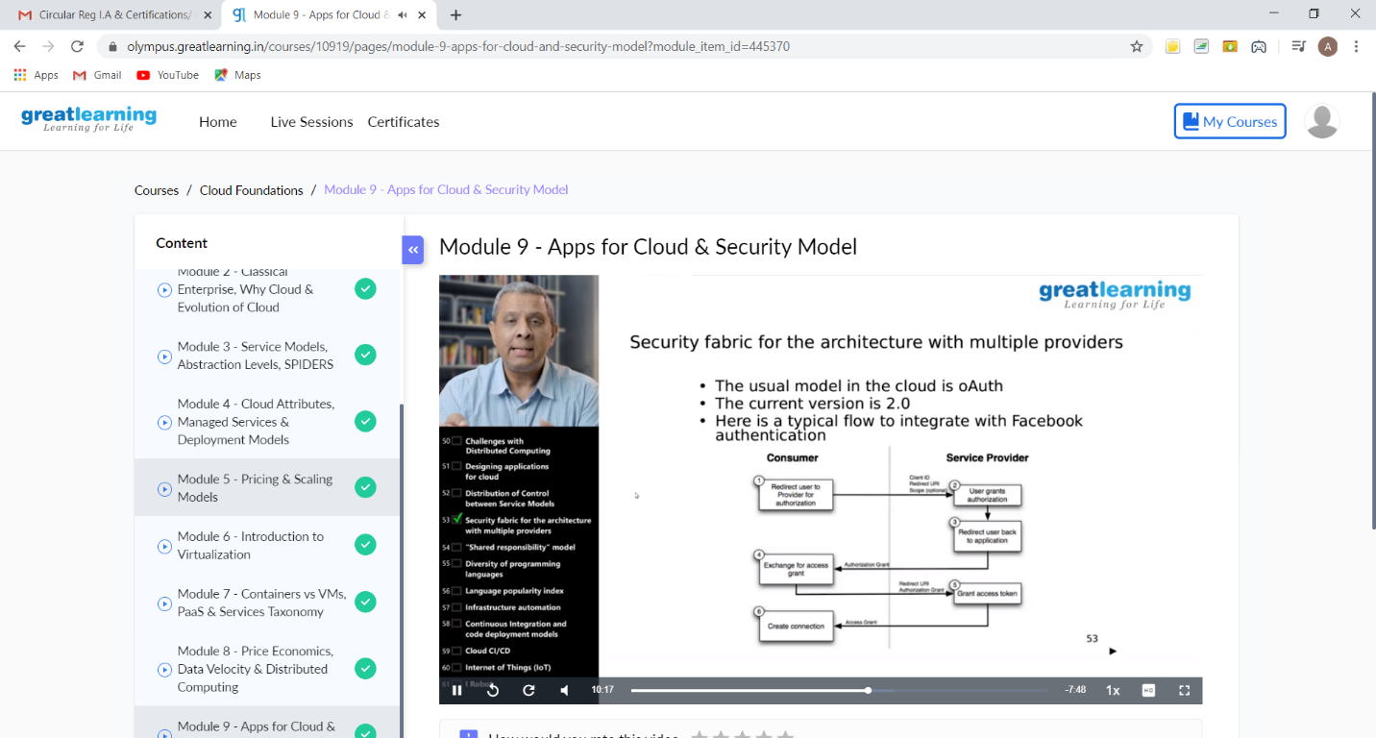

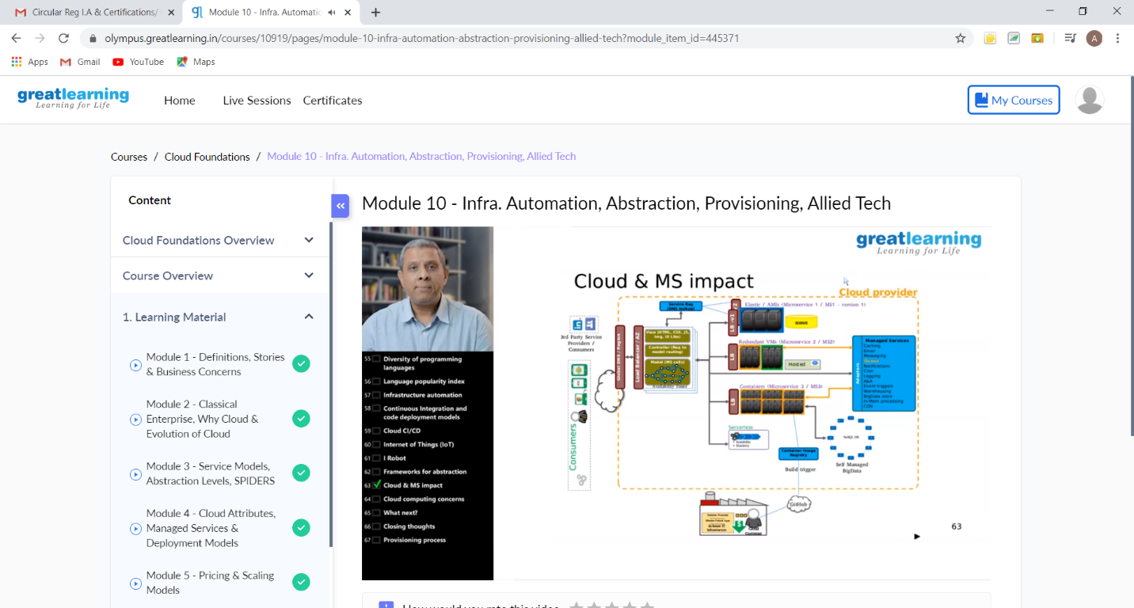

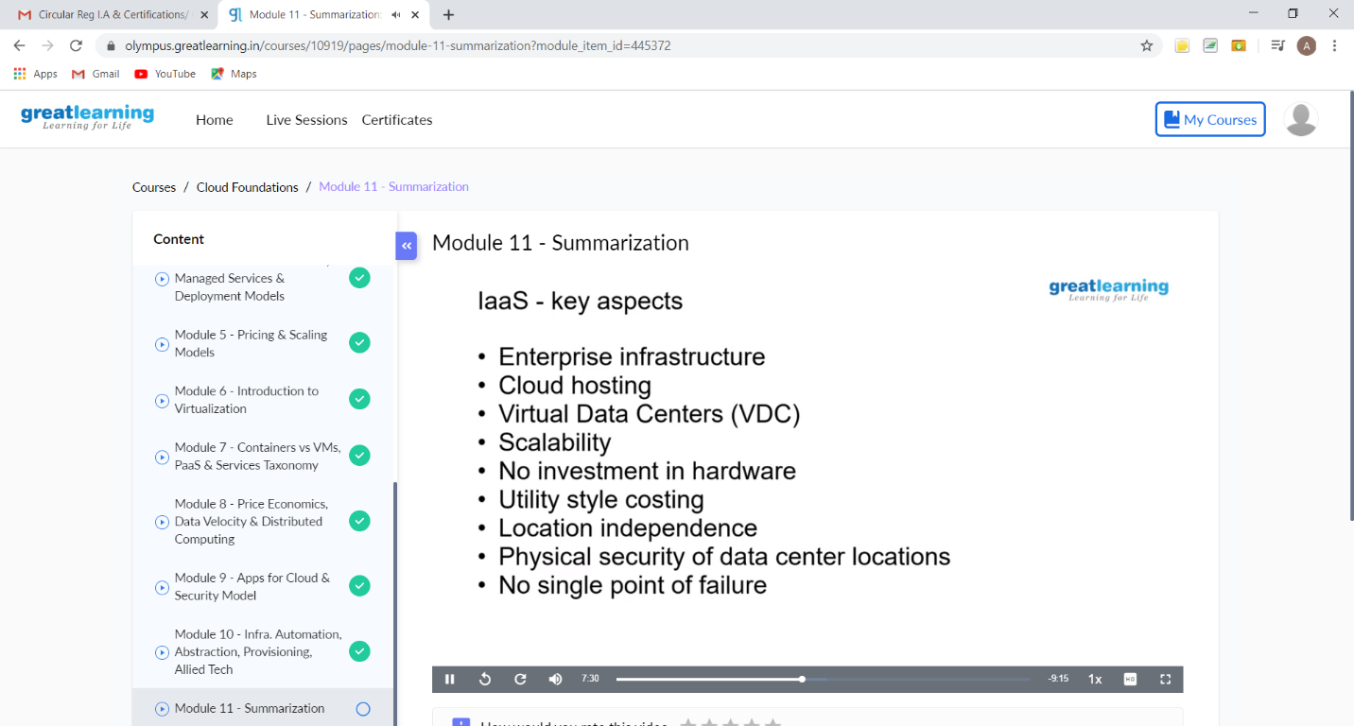

These are the Snap shots of today’s sessions.

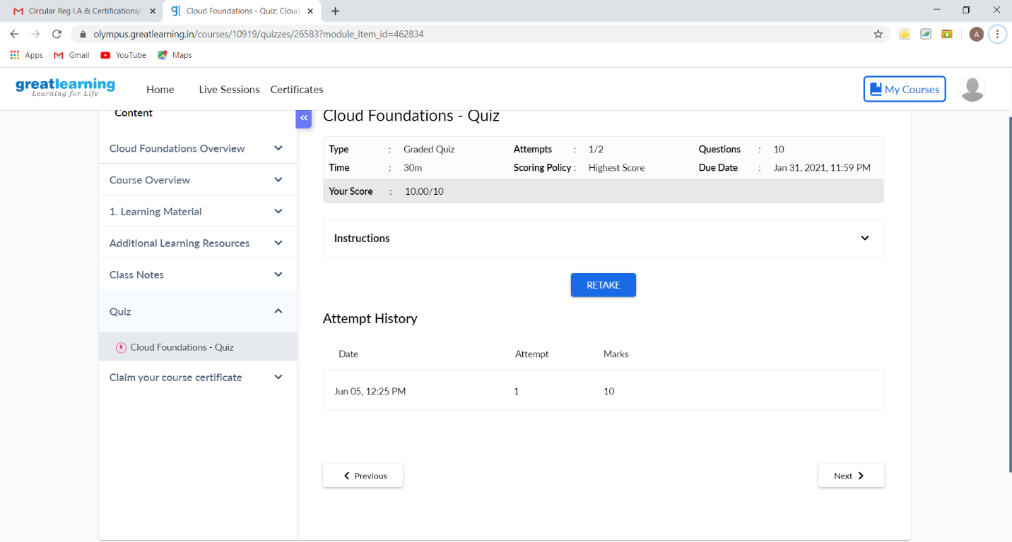

This is the snapshot of the quiz taken

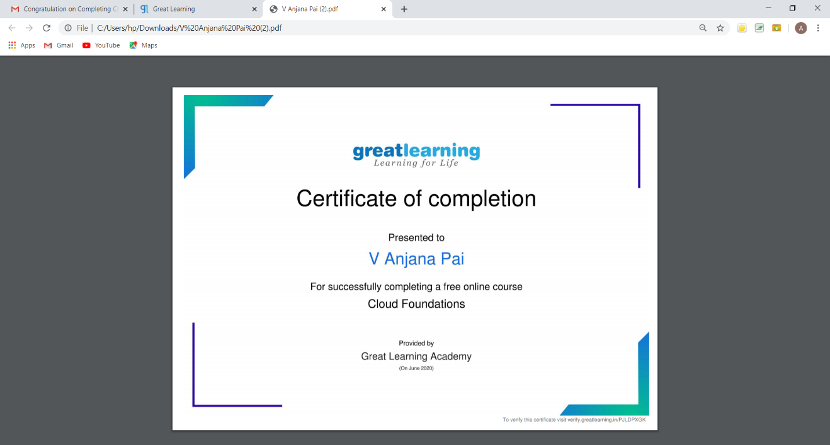

This is the snapshot of the certificate obtained after completion of the course.

Online Coding Summary: **Today I had received one program from prof. Reena Lobo CSE Dept. The programs are mentioned above in the coding challenges(pg.01). I have also uploaded it to my Github repository.**

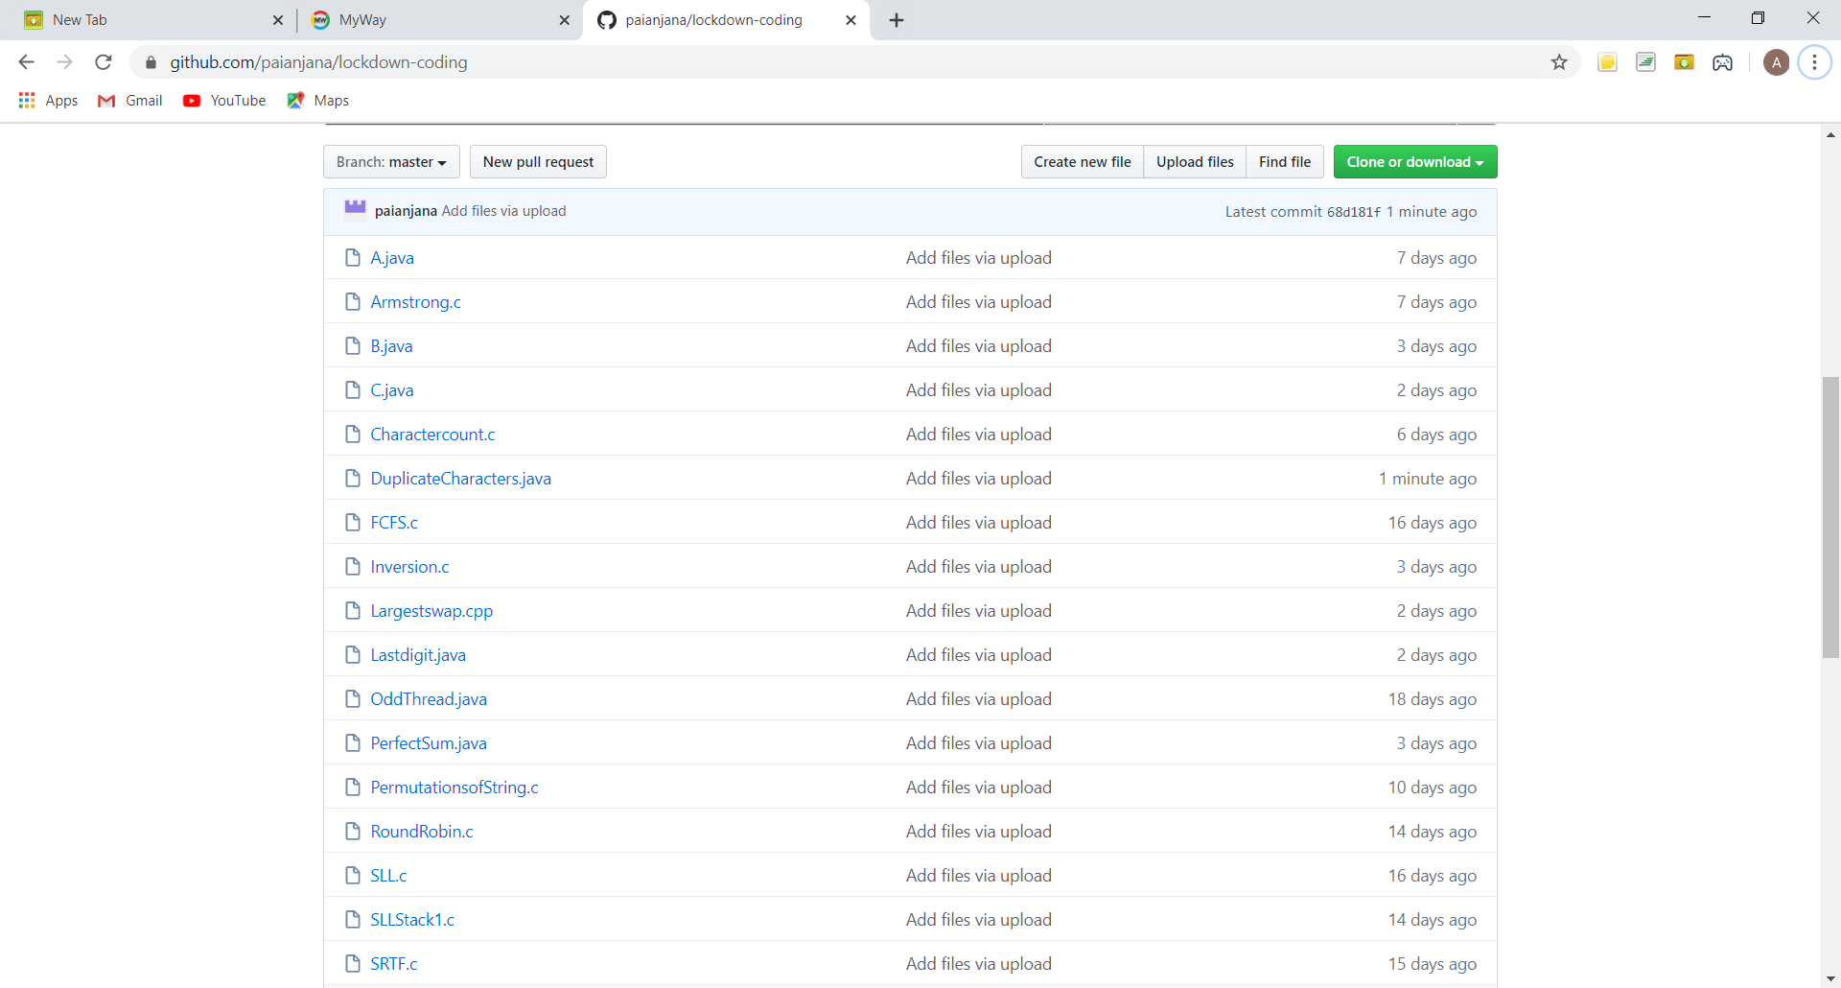

It is the snap shot of my repository where I have uploaded the code. File name is DuplicateCharacters.java